**EX. NO:**

**DATE :**

**Linear regression model to predict the signal strength**

**AIM:**

To develop a linear regression model to predict the signal strength

based on the distance.

**PROGRAM**

**:**

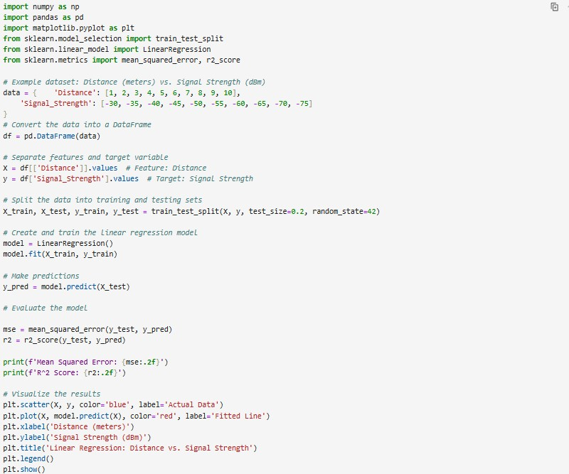

EX. NO: 07

DATE : 12/04/2024

220801140

**OUTPUT:**

Mean Squared Error: 0.00

R^2 Score: 1.00

**RESULT**

**:**

The program was executed successfully.

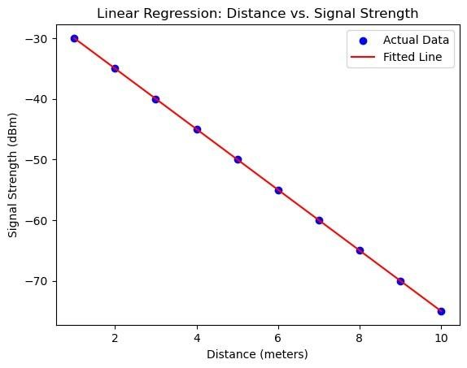

220801140